DOCUMENT APPROVAL SYSTEM
@CREATIVITY THINK (9483175986/7019689991)

ABSTRACT:
The Document Approval System is a web-based platform designed to streamline the submission, tracking, and approval of organizational documents. Users can upload documents, monitor their status, and receive updates through an intuitive dashboard. Administrators can manage workflows, approve or reject documents, and generate analytical reports with ease. Developed using Django and the Django Rest Framework for backend processing, and React with Dropzone and axios on the frontend, the system ensures efficient document flow, transparency, and traceability for various office and HR operations..

INTRODUCTION OF THE PROJECT:
In many organizations, document approval is often managed manually through emails or physical files, leading to delays, miscommunication, and difficulty maintaining proper records. The Document Approval System replaces such traditional processes with a centralized and intelligent digital workflow. It enables structured submission, automated tracking, real-time status updates, administrative oversight, and dashboard analytics for organizational transparency. The platform provides a secure environment for handling sensitive documents while reducing approval time and enhancing operational efficiency..

PROJECT OBJECTIVES:

• Enable users to upload and submit documents easily
• Provide real-time approval status tracking
• Create a structured and transparent approval workflow
• Enable administrators to approve or reject documents efficiently
• Provide dashboard analytics and detailed reports
• Reduce manual errors and delays in document processing
• Improve communication between users and approvers
• Ensure secure storage and handling of documents

PROBLEM OF THE STATEMENT:
Many organizations rely on inefficient, paper-based, or email-based document approval procedures. Such traditional methods result in delayed responses, lost documents, lack of tracking mechanisms, and no unified dashboard for analysis. The absence of automation also disrupts workflow productivity. The Document Approval System solves these issues by offering a centralized platform for submission, approval management, real-time tracking, and analytics. It ensures complete transparency, reduces administrative burden, and enhances workflow reliability..

MOTIVATION OF THE PROJECT:
• To eliminate manual document processing delays
• To improve transparency in approval workflows
• To provide an automated mechanism for tracking document status
• To create accountability in organizational processes
• To ensure secure handling and centralized storage of documents

BLOCK DAIGRAM OF PROJECT:

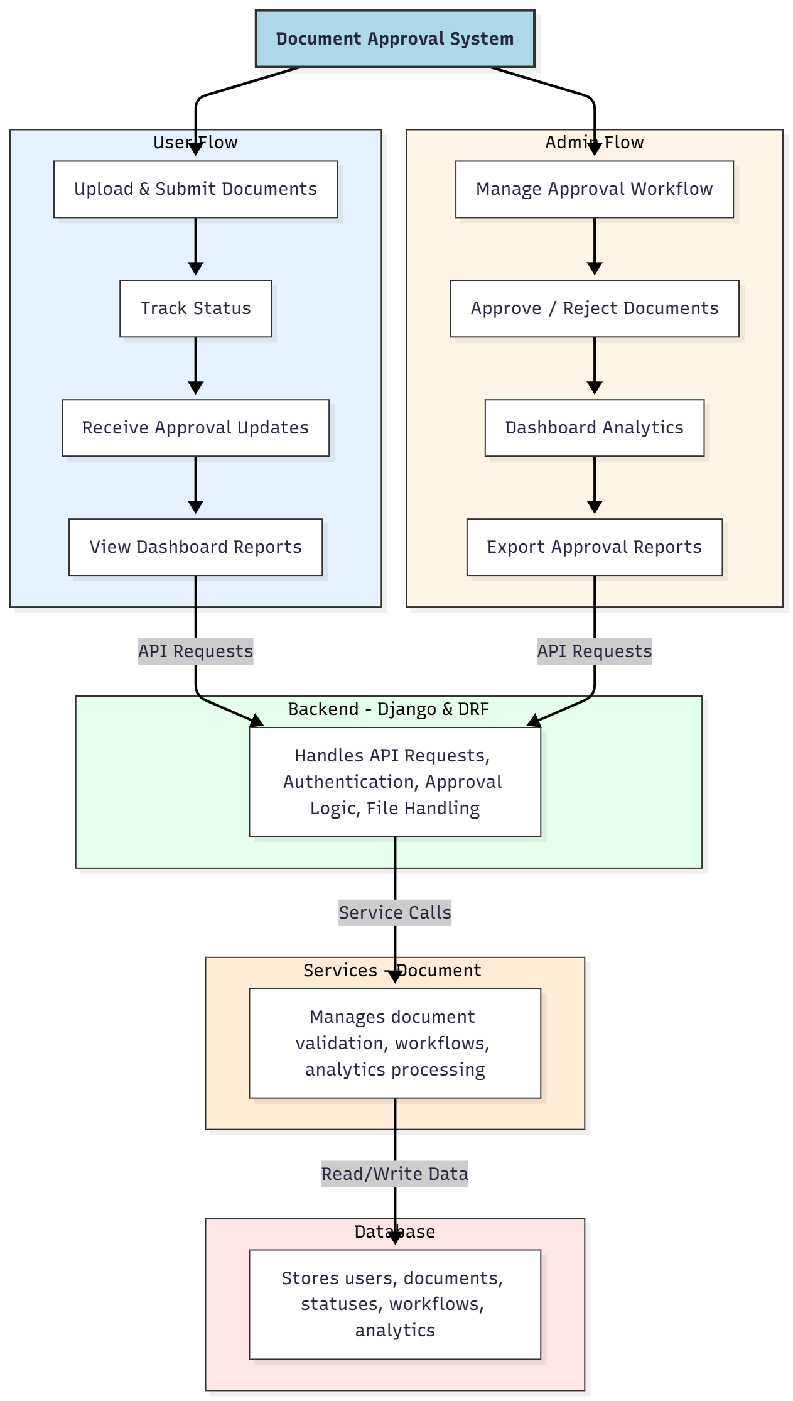

WORKING OF THE PROJECT:
The Document Approval System functions through a sequence of structured operations. A user begins by uploading a document using the submission interface, where files are validated and forwarded to the backend. The backend logs the submission, assigns workflow steps, and updates the approval pipeline. Administrators access pending documents, review content, and either approve or reject them with remarks. Users are notified instantly about changes through status updates displayed on their dashboards. The system services generate analytics, while the database securely manages documents, users, and approval data. This complete cycle ensures efficient tracking, transparency, and improved organizational workflow..

SOFTWARE REQUIREMENT:
- Backend:
  - Python 3.x
  - Django
  - Django REST Framework
  - SQLite/PostgreSQL
- Frontend:
  - Node.js and npm
  - React.js
  - Axios
- Development Tools:
  - Visual Studio Code
  - Postman (for testing APIs)
  - Git/GitHub (for version control)
- Server/Deployment (Optional):
  - Gunicorn, Nginx, or Heroku/AWS for hosting

ADVANTAGES OF THE PROJECT:

• Simplifies document submission and approval processes
• Reduces manual errors and approval delays
• Provides real-time status monitoring and notifications
• Offers comprehensive dashboard analytics
• Ensures secure storage and tracking of sensitive documents
• Improves workflow transparency and accountability
• Supports file handling and standardized approval cycles
• Enhances productivity across organizational departments

APPLICATIONS OF THE PROJECT:
• Office and corporate document approval
• HR policy submissions and employee documents
• Internal workflow and process management
• University or institutional approval systems
• Government or administrative file handling
• Multi-level approval chains for compliance
• Document monitoring dashboards for managers
• Report generation for audits and reviews

REFERENCES:

- Django REST Framework Documentation — Django Software Foundation. Django Documentation. Available: https://docs.djangoproject.com/
- Django REST Framework. DRF Documentation. Available: https://www.django-rest-framework.org/
- React. React Official Documentation. Available: https://reactjs.org/docs/getting-started.html
- Redux. Redux Documentation. Available: https://redux.js.org/introduction/getting-started
- PostgreSQL Global Development Group. PostgreSQL Documentation. Available: https://www.postgresql.org/docs/
- MySQL. MySQL Reference Manual. Available: https://dev.mysql.com/doc/
- Git. Git Documentation. Available: https://git-scm.com/doc
- Node.js. Node.js Documentation. Available: https://nodejs.org/en/docs/
- Axios. Axios Documentation. Available: https://axios-http.com/docs/intro
- Socket.io Documentation – https://socket.io/docs/

